Complete all questions in 1 hour.

1. Start the "Command Prompt" from the Windows Start Menu (Start -> Accessories -> Command Promtp).

**Answer:**

1. Use cd, cd.., cd/.. commands to navigate through the directories.

Create the Directory HCK on the desktop.

**Answer:**

1. List the files in the current directories. Make use of commands cls, exit to clear the screen and exit the prompt.

**Answer:**

1. Create a New.txt file containing the text *“Herald College Kathmandu”*, in the HCK directory.

**Answer:**

1. Delete the New.txt file from the HCK directory.

**Answer:**

1. Remove the directory HCK from the Desktop.

**Answer:**

1. Create a directory Kathmandu on the desktop containing file Swyambhu.txt,

Rename Swayambhu.txt as Barahi.txt

**Answer:**

1. Create Directory Pokhara on the Desktop and move Bahari.txt of the directory Kathmandu to the directory Pokhara.

**Answer:**

1. Write the python program in IDLE which takes two inputs from the user and returns the sum of the two numbers. Run this program from the command prompt.

**Answer:**

1. Run the logsim program from the command prompt.

**Answer:**

1. Create the following structure and take a Screenshot. Paste your result here.

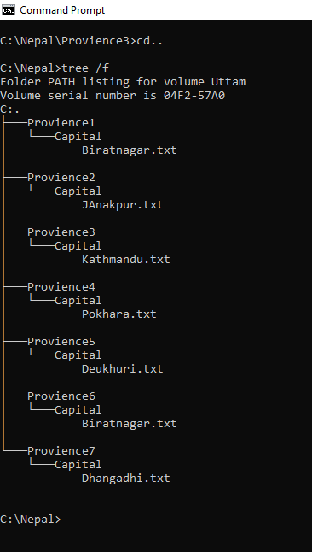

For more details about Commands you can type ***Help***which lists all the internal commands:

**Answer:**

Thank You